Joseph banks Secondary School Year 11 ATAR Psychology 2021

Joseph Banks Secondary School

Year 11 ATAR Psychology

Assessment Task 1 – In-class Test

65 marks (5% Response)

**MARKING KEY**

**OUTCOMES:**

|  |  |
| --- | --- |
| *Outcome 1:* | *Psychological understandings* |
| *Outcome 3:* | *Applying and relating psychological understandings* |
| *Outcome 4:* | *Communication in psychology* |

**ALLOCATED TIME FOR THE TASK:**

*You will have one period to complete this test in class*.

**INSTRUCTIONS:**

*Attempt all questions*

*No notes, files, mobile phones etc. to be accessed during the test*

|  |  |
| --- | --- |
| **Section One – Research Methods** | |
|  |  |
|  |  |
| **Total** | **/25** |

|  |  |
| --- | --- |
| **Section Two – Short Answer** | |
| Question 4 | / 8 |
| Question 5 | /4 |
| **Total** | **/ 27** |

|  |  |
| --- | --- |
| **Total Marks** | |
| Section 1 | / 30 |
| Section 2 | / 37 |
| **Assessment Task 1 – Total Marks** | **/ 67** |

Teacher comment: _________________________________________________________________________________

_________________________________________________________________________________

_________________________________________________________________________________

**Question One (8 marks)**

Read the following scenario and answer the questions that follow

Renowned Perth Psychologist, Dr Wrona, was interested in the relationship between sleep levels and an individual’s mood state. After putting an advertisement in a local newspaper, she gathered 50 volunteers (ages 18-65), who experienced the following hours of sleep per night:

1-4 OR 6-9. She then asked them a series of open-ended questions in her clinic in order to understand the nature of their respective mood states

a) Identifythe Independent Variable/s. (1 mark)

|  |  |
| --- | --- |
| **Descriptor** | **Mark** |
| (1) Oper Amount of sleep per night | 1 |

b) State the Dependent Variable. (1 mark)

|  |  |
| --- | --- |
| **Descriptor** | **Mark** |
| (1) Oper Mood | 1 |

c) Create an operationalised hypothesis for this research study. (4 marks)

|  |  |
| --- | --- |
| **Descriptor** | **Mark** |
| (1) Operationalised IV and DV, (1) Population (1) compare to a control (1) direction  It is hypothesised that adults between 18-65 who receive 609 hours of sleep per night will report a better mood as measured by open-ended interview questions than adults ages 18 – 65 who receive 1-4 hours of sleep | 4 |

d) Outline the type of data collected by the psychologist. (2 mark)

|  |  |
| --- | --- |
| **Descriptor** | **Mark** |
| (1) Oper Subjective  Qualitative  Q | 1  1 |

e) Describe one disadvantage/limitation of using this form of data. (1 mark)

|  |  |
| --- | --- |
| **Descriptor** | **Mark** |
| (1) Oper Either  Subjective – based on personal opinion therefore  Qualitative - takes a lot of time to analyse  Accept any other relevant and correct evaluation | 1  1 |

f) Describe another type of data that Dr Wrona should use in conjunction with the data she has already collected. (2 marks)

|  |  |
| --- | --- |
| **Descriptor** | **Mark** |
| Either –  Objective data: using observations by researchers to assess participant moods  Quantitative: Using close-ended or fixed-response questions to gather numeric results | 1 identify  1 describe |

**Question Two (5 marks)**

A research study was conducted to examine the effects of alcohol consumption and developing feelings of sadness. Fifty participants were randomly assigned to Group A or Group B.

Individuals performed the following sequence of tasks

Completed a mood rating scale

Discussed with the researcher three recent times when he/she felt sad:

Completed the mood rating scale again

Drank a moderate dose of ‘alcohol’ over a 20 minute period

Waited 20 minutes for the alcohol to be absorbed

Completed the mood rating scale again.

All participants were told that they would be given a moderate dose of alcohol to drink but only participants assigned to Group A were actually given alcohol. Group B were given a non-alcoholic beverage that appeared to be alcohol.

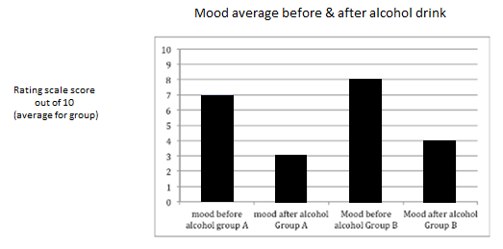

g) a) Figure 1 above summarises some findings of the study described above. State the conclusion/s from these findings. (2 marks)

|  |  |
| --- | --- |
| **Descriptor** | **Mark** |
| (1) Oper Accurately states the above numeric data in words. No interpretation(s) given. 1 mark per result e.g.  *Group A had a average mood score of 7 out of 10 prior to drinking alcohol whereas after drinking alcohol the average mood score was 3 out of 1* | 1 |

**Question Three (14 marks)**

1. Dr Stevens conducted a study with a group of Psychology students to determine the relationship between the numbers of hours spent studying Psychology per week and the final examination score.  The results of this study are shown in the table below.

a) State the median examination score from this group. (1 mark)

|  |  |
| --- | --- |
| **Descriptor** | **Mark** |
| (1) Q 65% | 1 |

b) Calculate the mean number of hours studied by this group. (1 mark)

|  |  |
| --- | --- |
| **Descriptor** | **Mark** |
| 10 hours | 1 |

c) Plot a scattergram of these scores on the axes provided. Label the scattergram appropriately. (5 marks)

|  |  |
| --- | --- |
| **Description** | **Marks** |
| One mark to be allocated to each of the following points:  • Horizontal axis labelled with units (either variable as they are behavioural) (1 mark)  • Vertical axis labelled with units (1 mark)  • Correct title (Relationship between the numbers of hours spent studying Psychology per week and the final examination score.) (1 mark)  • Use of dots (not a line graph) (1 mark)  • Correct graphing of all data from the table (1 mark) | 1  1  1  1  1 |
| **Total** | **5** |

**Question Four (8 marks)** Researchers are designing an experiment to determine whether listening to music while exercising causes people to exercise harder. There will be 100 participants in the experiment, 50 in the experimental group, and 50 in the control group.

a) List two variables that should be controlled in this experiment. (2 marks)

|  |  |
| --- | --- |
| **Descriptor** | **Mark** |
| (1) Oper Type of music and length of exercise | 1 |

b) Identify one ethical consideration relevant to this study. Explain how the researchers would deal with this consideration in their research. (2 marks)

|  |  |
| --- | --- |
| **Descriptor** | **Mark** |
| 1 mark for ethical consideration and 1 mark for appropriate action.  **Informed consent/ Underage participants:** guardians receive information and sign to agree to participation.  **Withdrawal rights:** can leave study any time without ramifications/ pressure  **Confidentiality:** share no personal details  **Voluntary participation:** Do not coerce participants; compensation to be commensurate.  Q | 1  1 |

e) In research what is meant by the term reliability (1 mark)

|  |  |
| --- | --- |
| **Descriptor** | **Mark** |
| (1) Oper consistency of a research study or measuring test | 1  1 |

f) In research what is meant by the term validity (1 mark)

|  |  |
| --- | --- |
| **Descriptor** | **Mark** |
| (1) Qthe extent to which a test measures what it claims to measure | 1  1 |

g) Using an example explain the difference between a population and a sample. (2 marks)

|  |  |
| --- | --- |
| **Descriptor** | **Mark** |
| The population is the whole group of individuals under investigation that results need to apply to  The sample is the selected group that shall be used in the research | 1  1 |

**Section 2- Short Answer Questions- 5 Questions (21 marks)**

**Question Five (5 marks)**

1. Identify the parts of the neuron below (4 marks)

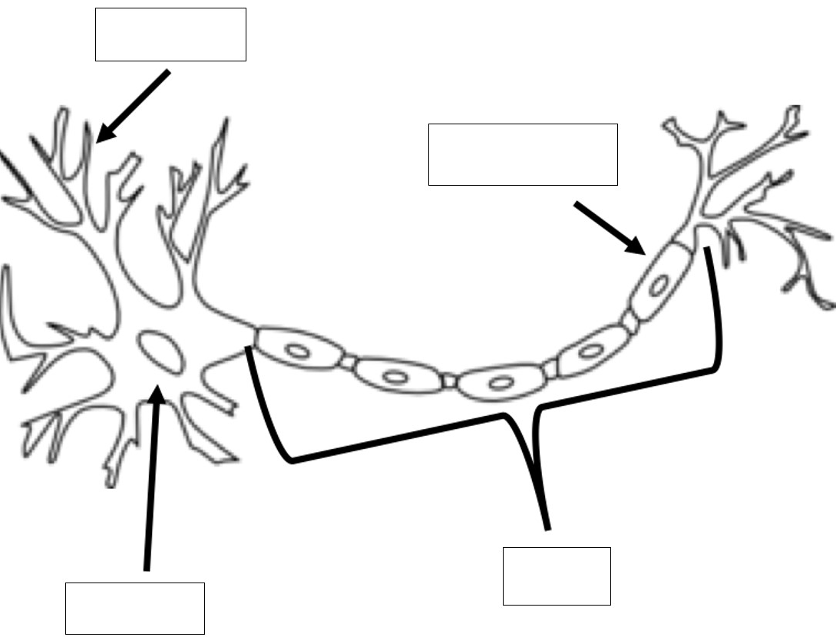

b) Outline the direction of neural transmission (1 mark)

|  |  |
| --- | --- |
| **Descriptor** | **Mark** |
| (1) Oper `From dendrite to axon terminal | 1 |

**Question Six (8 marks)**

1. Identify the location and function of the reticular formation (2 marks)

|  |  |
| --- | --- |
| **Descriptor** | **Mark** |
| 1. Oper Located mainly in the midbrain (1) main role is to control the alert / sleepiness levels 2. Fjo | 1 |

1. Circle which area of the brain is the cerebellum formation located in: (1 mark)

Forebrain **Hindbrain** Midbrain

1. Outline the key functions of the hindbrain (2 marks)

|  |  |
| --- | --- |
| **Descriptor** | **Mark** |
| (1) Oper  To ensure the **basic physiological responses necessary for life** are maintained  Such as heart rate, breathing rate, digestion, etc. | 1  1 |

1. Name the brain lobes and the functions of eachin the table below. (4 marks)

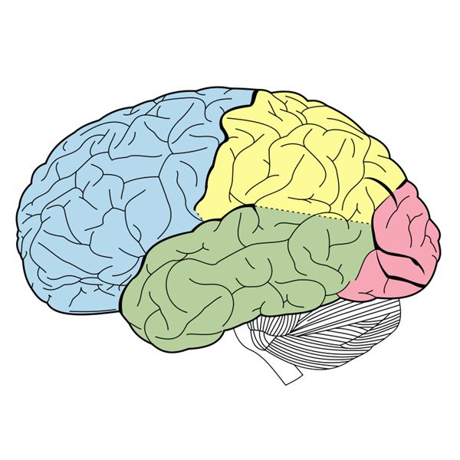

Lobe B

Lobe A

Lobe D

Lobe C

|  |  |  |
| --- | --- | --- |
| **Lobe** | **Lobe Name** | **Lobe Function/s** |
| A | Frontal lobe | Problem solving, critical thinking, emotional regulation |
| B | Parietal | Sensory information related to touch |

Allen got up during the night to get a glass of water. While walking to the kitchen, he heard a sudden, loud noise. He was so scared that he tripped and fell, hitting his head on the wall. Since then, he has had difficulties with his vision, though there’s been no change in his ability to understand what people are saying or respond to them.

e) Which of his lobes seems most likely to have been injured? (1 mark)

|  |  |
| --- | --- |
| **Descriptor** | **Mark** |
| Occipital |  |

f) Which of his lobes was most involved in processing the sound in the first place? (1 mark)

|  |  |
| --- | --- |
| **Descriptor** | **Mark** |
| Temporal |  |

**Question Seven (10 marks)**

1. Identify one example of a stimulant and describe one psychological and one physiological effect that the drugs can induce: (3 marks)

|  |  |
| --- | --- |
| **Descriptor** | **Mark** |
| Caffeine, Cocaine, Meth  Psychological effect: increased focus, decreased attention span, increased talkatively, decreased inhibition  Physiological effect: Increased heart rate, increased blood pressure | 1  1  1 |

1. Identify one example of a depressant and describe one psychological and one physiological effect that the drugs can induce: (3 marks)

|  |  |
| --- | --- |
| **Descriptor** | **Mark** |
| Alcohol, Marijuana,  Psychological: Slower reaction times, slurred speech  Physiological: decrease activity of CNS, decreased heart rate | 1  1  1 |

c) It has been suggested that exercise can be as effective as drugs in altering mood,

especially in reducing symptoms of depression. There are several factors that may

account for the way in which exercise enhances mood.

Explain **two** (2) factors that account for the way in which exercise enhances mood. (4 marks)

|  |  |
| --- | --- |
| **Descriptor** | **Mark** |
| Increase in the levels of feel-good neurotransmitters in the brain  Improves sleep and energy levels  **Accept any other relevant answer** |  |

**Question Eight (4 marks)**

In class you have examined two case studies that investigate how injuries to the brain can impact on a person’s thoughts, emotions and behaviour. The first of these case studies was Phineas Gage, the railway worker who had a metal rod shot through the frontal lobe of his brain. The second case study was Sasha Sabet, the young girl who had her right hemisphere removed to stop her severe epileptic seizures.

Explain with reference to **one (1)** of these case studies, how it has increased your understanding of the role and functions of parts of the brain. Ensure you:

* briefly outline why the person became of interest to psychologists
* identify what parts of the brain were involved
* explain what changes to their thoughts, emotions and/or behaviour occurred, or were possibly going to occur, as a result of their experience

|  |  |
| --- | --- |
| **Descriptor** | **Mark** |
| Phineas Gage become of interest to psychologists as he was the first case study of an individual having a pole shot through his frontal lobe and surviving. The areas involved were the frontal lobe and the limbic system  Prior: pleasant, easy-going, even tempered, able to hold down a job  After: Quick to anger, not very rational |  |